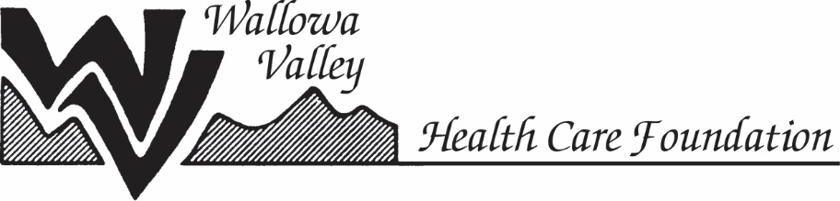
Scholarship Application 2021

Must be postmarked or hand delivered by June 2, 2021

Please indicate the scholarship you are applying for

Gwen and Gladys Coffin Memorial Scholarship

Edgar and Frances Boyd Burbridge Scholarship

Name:__________________________________________

Address:____________________________________________

Phone:________________________email:_________________

Current employer:______________________________________

Position/Title:_________________________________________

How long have you held this position, and worked for this employer?____________________________________________
___________________________________________________

Please answer the following questions briefly. Answers may be typed on a separate piece of paper.

- Briefly describe the education/training you are seeking, where you are planning to receive it, and why you are seeking it
- Briefly explain how you receiving this education/training will help improve health care services in Wallowa County
- Attach a simple budget, outlining the estimated costs of your program including:
  - Tuition and fees
  - Books/training materials
  - Travel expenses associated with the program
  - Any other costs associated with the program

Please refer to the flyer for additional items you need to include
for a complete application. Thank you.

